Spike: Task 16
Title: Sound Board
Author: Mohamed Shafi Uzman Fassy, 102608927

Goals / deliverables:
The goal of this spike task is to demonstrate my ability to use a framework to load, play and control game sound and music using SDL2 and SDL2 mixer.

Besides this report, what else was created?
- Code files in see C:\Users\storm\Documents\GitHub\GAMES PROGRAMMING REPO\COS30031-2023-102608927\16 - Spike - Sound Board\SDLMixerTask\SDLMixerTask.
Technologies, Tools, and Resources used:
List of information needed by someone trying to reproduce this work.
- Visual Studio 2022 Community Edition
- GitHub
- Game Specification Details Canvas Module
Tasks undertaken:
- Watching SDL2 Mixer Installation Guide Videos
- Setting up Project environment to use SDL2 and SDL2 Mixer
- Download 4 sound files.
Implementing SDL2 and SDL2 Mixer:

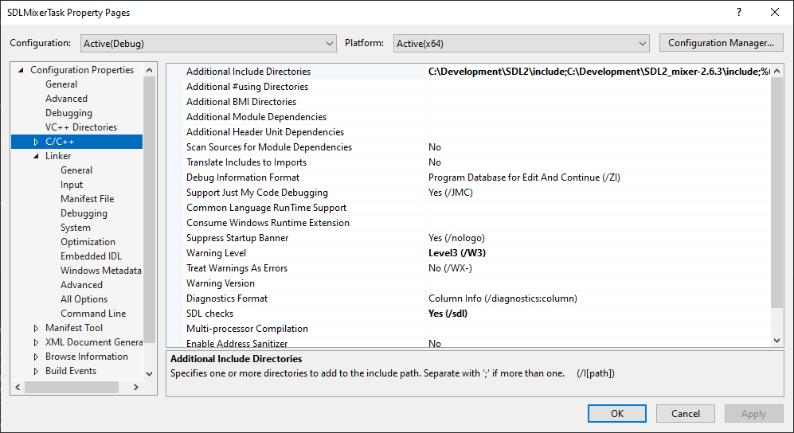

Once I downloaded the SDL2 and SDL2 mixer libraries I had to add them into the additional include directories in my project properties settings.

How we Initialize the sounds:

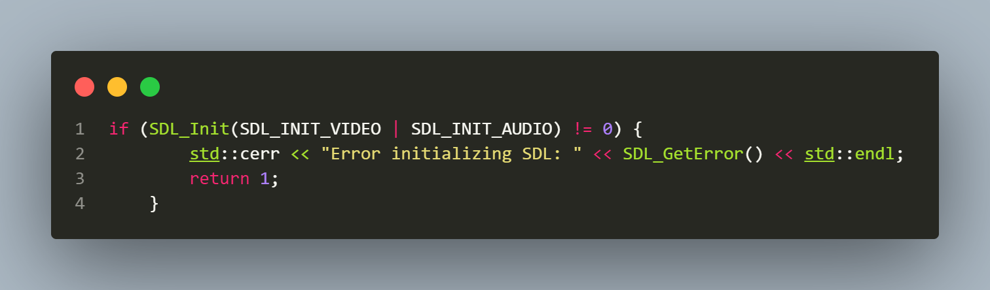
The first step towards playing sounds in SDL is initializing the SDL library itself, with a focus on the video and audio subsystems. This is accomplished with the SDL_Init() function.
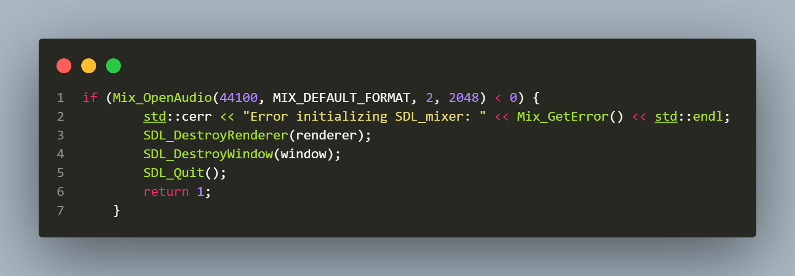
Once SDL is initialized, we need to set up the SDL_mixer, which is an SDL library extension that allows us to play sound files. To do this, we use the Mix_OpenAudio() function. This function sets the audio format for our application. We are initializing the audio rate to 44100Hz, using the default format, setting the output to stereo (2 channels), and using a chunk size of 2048 bytes.
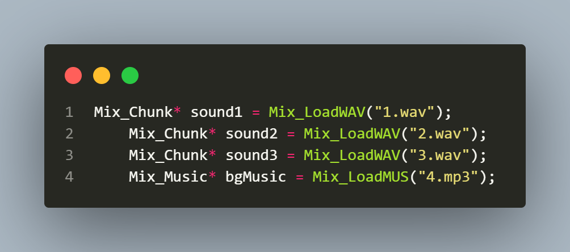
Before playing sounds, we must loaded them onto the memory. With SDL_mixer, we use the Mix_LoadWAV() function for sound effects (short audio clips) and Mix_LoadMUS() for music (longer audio tracks).

How we play the sounds:

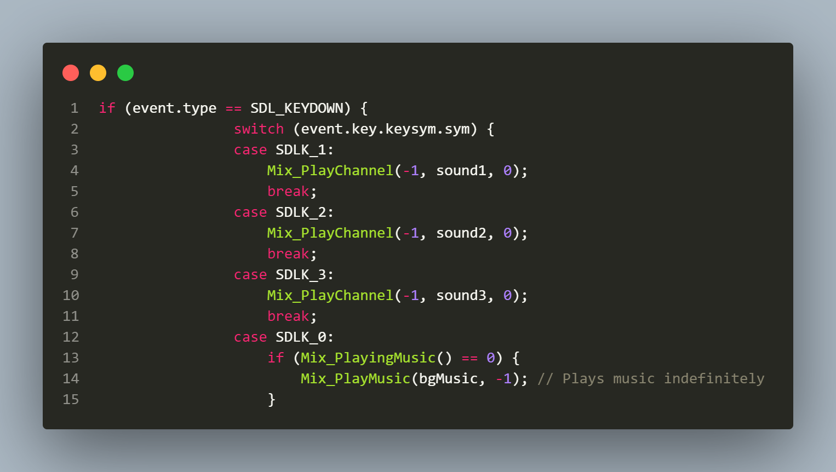
Once the sounds are loaded into the memory as chunks, they can be played using the Mix_PlayChannel() function. The first argument specifies the channel to play on (-1 means to play on the first free channel), the second argument is the sound chunk to play, and the third argument is the number of times to loop (0 means play once). The music file is played using the Mix_PlayMusic() function. The first argument is the music data loaded into memory, and the second argument is the number of times to loop (-1 means loop indefinitely).

How we pause the sounds:
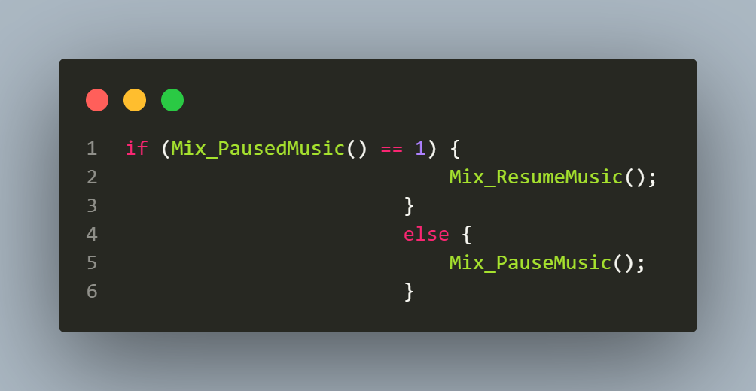
If there is music playing, the code then checks if the music is currently paused using the Mix_PausedMusic() function. Depending on whether the music is paused or not, it either resumes the music using Mix_ResumeMusic() or pauses the music using Mix_PauseMusic().

